Documentation on

Online Real estate Business

[Document subtitle]



Prepared by

Under Guidance of

Lajja Choksi

Sem -6 of Year 2020-21

By

185170693010 Raj Dinesh Parmar

195173693041 Venkata Siva Balaji Itika

195173693104 Sudarshan Bibhas Dey

**L.J. INSTITUTE OF COMPUTER APPLICATIONS**

Near Nagdev Kalyan Mandir, Near Sanand Cross Roads,

Sarkhej-Gandhinagar Highway Ahmedabad - 382481



***CERTIFICATE***

**Enrollment No**: 185170693010

195173693041

195173693104 **Seat No:** _____________

This is to certify that Mr. Raj Dineshbhai Parmar, Itika Venkata Siva Balaji and Sudarshan Dey of Master of

Computer Applications, Semester 6 has satisfactorily completed her Project titled Online Real Estate Business under the supervision of Lajja Choksi.

**Internal Guide Name: Lajja Choksi** **Signature**

**Date of Submission: HOD**

**Director**

Introduction:

**1.1Project purpose:**

Our project report is on Online Real Estate Business website through which user can register details of the property for rent/lease/sell in the website. So user can add/update/delete the assets and some tasks of it.

The Admin user can change the updated information regarding property selling and buying and cancellation.

The system is very useful for the companies who construct the apartment, villas, individual house and who want to purchase or rent.

Companies and agents can also register the property of their own.

ReMa focuses on real estate business. Broker has essential role in real estate business. Broker is a mediator between Consumer and Property owner. In ReMa Property Owner advertise property, Consumer shows interests in the property by selecting it.

ReMa generates lead which will be assigned to Broker by Admin.

Lead: Lead is a term for work which is assigned to a real estate agent.

**Scope:**

ReMa is targeting consumers interested in real estate, property owners, Creditors and individual real estate Agents (Brokers). Properties can be residential or commercial in our system. Creditors will lend loan to Buyers based on the valuation of property. Creditors can be an individual or a private institutions like Credit Society or Banks.

**Existing System:**

In existing system, a consumer visits for two purposes which is renting/buying a property. Customer enters the criteria which includes Price Range, Location and type of property.

The list of properties are displayed according to search criteria.

Consumer selects a property. The System notifies the broker about the customer. If Customer agrees to buy a property then he can apply for Home Loan Schemes given by Creditors.

**Proposed System:**

**Users:**

There are five kinds of users in ReMa. They are:

* Property Owner: Advertises property for selling/renting.
* Consumer: Shows interest in property for buying or renting.
* Broker: Completes the lead assigned by admin.
* Creditors: Advertises Property loan schemes for buyers.
* Admin: The user who manages the System.

**Functionalities:**

Property Owner:

* Manage Contact info.
* Manage Property Details.
* View Broker assigned to your property.
* View Feedback related to property.

Consumer:

* Manage Contact info.
* Enter search criteria for property.
* Manage Property wishlist.
* Apply for Loan Scheme to buy property.
* View Broker of property in a wishlist.
* Give Feedback related to property.

Broker (Real Estate Agent):

* Manage Contact info.
* View Assigned Leads.
* Manage the Lead.

Creditors:

* Manage Contact info.
* Manage Loan Schemes for property.
* Manage Loan applicants.

1.2 UML Diagrams:

**1.2.1 Use Case Diagram:**

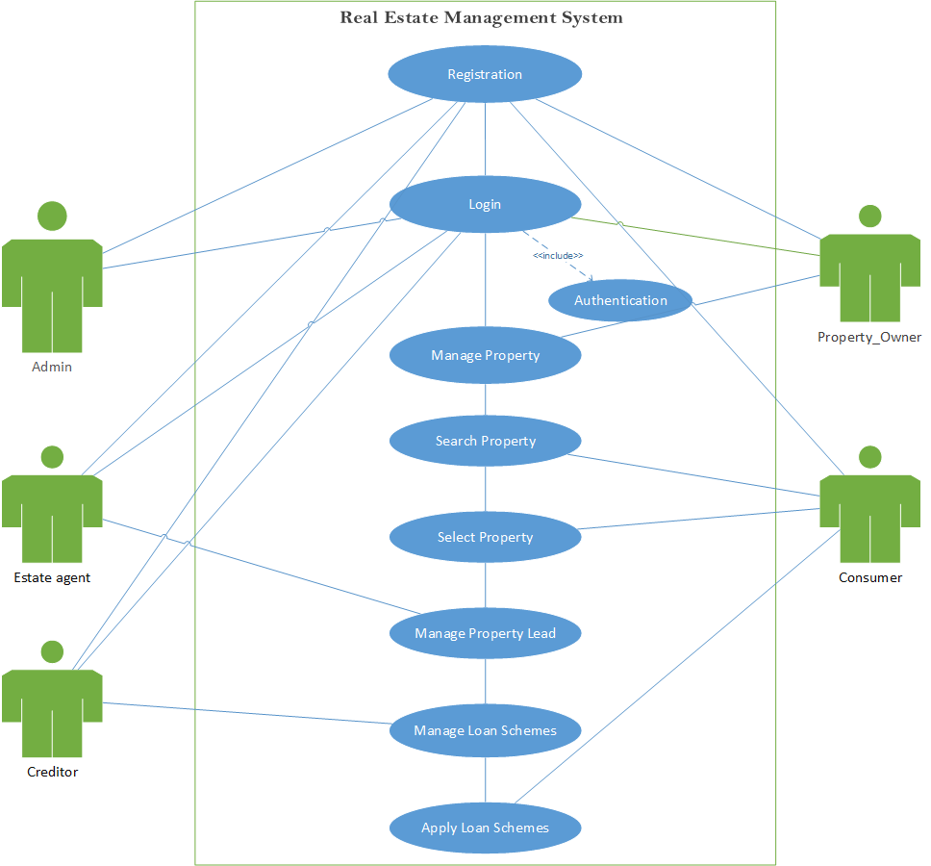

1.2.2 Class Diagram:

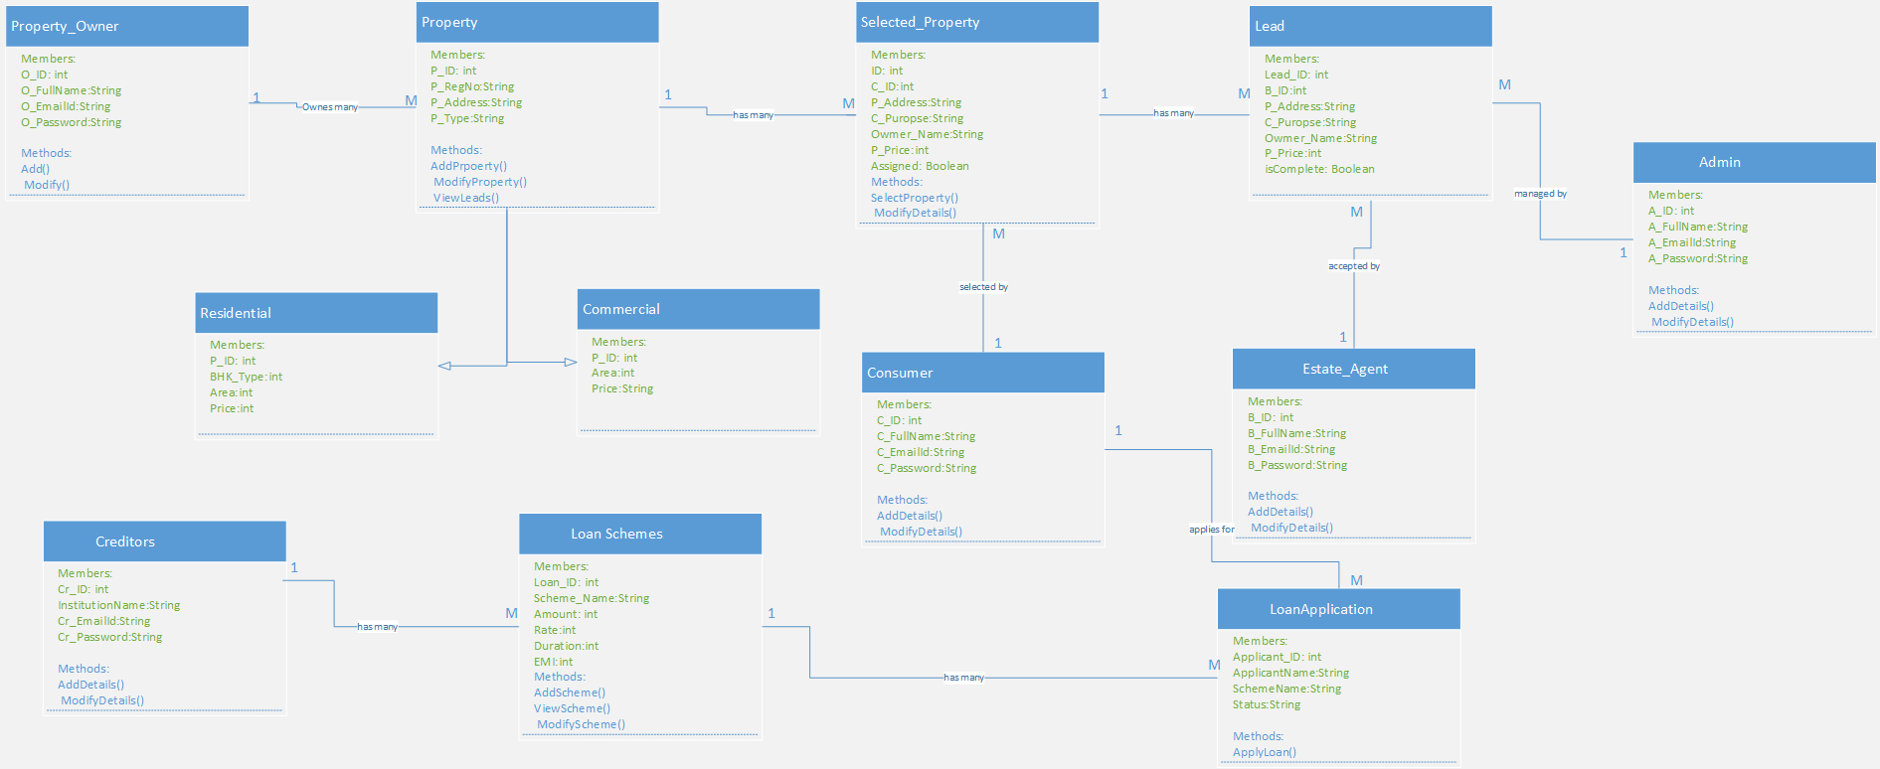

**1.2.3 Interaction (Sequence) Diagram:**

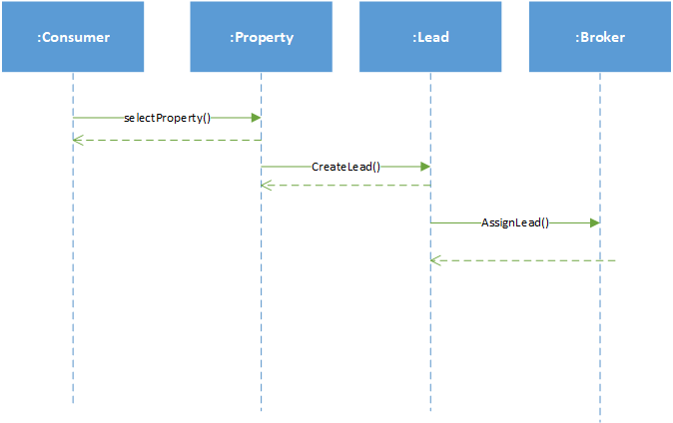

**1.2.4** **Data Dictionary**

**1.) UserMaster**

|  |  |  |  |  |  |
| --- | --- | --- | --- | --- | --- |
| **Data Item** | **Data Type** | **Data Format** | **Size** | **Description** | **Constraint** |
| User_ID | integer | 1 | **3** | **ID of admin** | **Primary Key** |
| FullName | string | FirstName,  LastName | **50** | **Full name**  **Of User** | **Not null** |
| HouseNo | string | “M-1/3” | **10** | House no of user | **Not null** |
| Society  Name | **string** | “Suramya Apartments” | **100** | Society where user lives | Not null |
| Locality | **string** | “VijayNagar” | **60** | Locality of address | Not null |
| Landmark | **string** | “Nr. CNG Pump” | **60** | Landmark for address | Not null |
| Area | **string** | “Naranpura” | **50** | Area of address | Not null |
| UserCity | string | “Ahmedabad” | **25** | City where user lives | Not null |
| UserDoB | **date** | “dd-mm-yyyy” |  | **Date of Birth** | **Not null** |
| Gender | **string** | “Male”,”Female” | **10** | **Gender of user** | **Not null** |
| UserEmail | string | “admin@gmail.com” | **25** | **Email ID** | **Unique, not null** |
| UserPhoneNO | **BigInt** | 7776661101 | **10** | **Contact number** | **Not null** |
| UserPassword | **string** | ********* | **20** | **Password of admin** | **Not null** |
| Role | **string** | “Owner”,  ”Broker”,  ”Consumer” | **10** | **Category**  **Of**  **User** | **Not null** |

**2.) Property**

|  |  |  |  |  |  |
| --- | --- | --- | --- | --- | --- |
| **Data Item** | **Data Type** | **Data Format** | **Size** | **Description** | **Constraint** |
| Property  ID | Integer | 1 | **3** |  | **Primary Key** |
| Owner ID | Integer | 1 | **3** | **Owner ID** | **Foreign Key** |
| RegNo | **String** | “PR11201” | **20** | Registration Number of property |  |
| HouseNo | String | “M-1/3” | **10** | House no of user | **Not null** |
| Society  Name | **String** | “Suramya Apartments” | **100** | Society where user lives | Not null |
| Locality | **String** | “VijayNagar” | **60** | Locality of address | Not null |
| Landmark | **String** | “Nr. CNG Pump” | **60** | Landmark for address | Not null |
| Area | **String** | “Naranpura” | **50** | Area of address | Not null |
| Property_City | String | “Ahmedabad” | **25** |  |  |
| Purpose | String | “Sale”,”Rent” | **25** |  | **Not null** |
| Type | **String** | “Commercial”,”Residential” | **10** | **Type of property** | **Not null** |
| Size | **integer** | 1221 | **6** | **Area of Property** | **Not null** |
| Sub_Type | **String** | “1BHK”,”2BHK”,:”Shop”,”Office” | **10** | **Sub Type of property** | **Not null** |
| Price | **bigInt** | 1000000 |  | **Expected price/rent for property** | **Not**  **null** |
| Status | **String** | “Sold”,”Rented”,”Active” |  | **Status of property** | **Not**  **Null** |
| Construction_Status | **String** | “Ready to Move”,”Resale” | **12** |  |  |

**3.) Lead**

|  |  |  |  |  |  |
| --- | --- | --- | --- | --- | --- |
| **Data Item** | **Data Type** | **Data Format** | **Size** | **Description** | **Constraint** |
| Lead ID | Integer | 1 | **3** |  | **Primary Key** |
| Property ID | Integer | 1 | **3** | **Property ID** | **Foreign Key** |
| Consumer ID | **Integer** | 1 | **3** | Consumer ID | **Foreign Key** |
| Owner ID | **Integer** | 11 | **3** | Owner ID |  |
| Property_Price | Integer | 100000 | **6** |  |  |
| Purpose | String | “Buy”,”Rent” | **25** |  | **Not null** |
| Assigned | **Boolean** | True,False |  |  | **Not null** |

**4.) AssignedLead**

|  |  |  |  |  |  |
| --- | --- | --- | --- | --- | --- |
| **Data Item** | **Data Type** | **Data Format** | **Size** | **Description** | **Constraint** |
| Assigned ID | **integer** | **1** | **3** |  | **Primary Key** |
| Broker ID | **integer** | **1** | **3** |  | **Foreign Key** |
| Lead ID | integer | 1 | **3** |  | **Foreign Key** |
| Status | **String** | **“Pending”,**  **”Complete”** | **10** |  | **Not null** |

**5.) LoanScheme**

|  |  |  |  |  |  |
| --- | --- | --- | --- | --- | --- |
| **Data Item** | **Data Type** | **Data Format** | **Size** | **Description** | **Constraint** |
| Loan ID | integer | 1 | **3** |  | **Primary Key** |
| Creditor ID | integer | 1 | **3** | **Owner ID** | **Foreign Key** |
| Scheme Name | **String** | “Commercial Scheme-1” | **20** | Scheme name of Loan | **Not null** |
| Institution Name | string | “Axis Bank Ltd” | **80** | Institution managing the loan | **Not null** |
| Amount | integer | 1000 | **7** | Principal amount for loan | Not null |
| ROI | integer | 5 | **3** | **Rate Of Interest** | **Not null** |
| Duration | **integer** | 3 | **4** | **Duration of Loan** | **Not null** |
| EMI | **integer** | 1221 | **5** | **Easy Monthly Installment** | **Not null** |

**6.) LoanApplicant**

|  |  |  |  |  |  |
| --- | --- | --- | --- | --- | --- |
| **Data Item** | **Data Type** | **Data Format** | **Size** | **Description** | **Constraint** |
| Applicant ID | integer | 1 | **3** |  | **Primary Key** |
| Loan ID | integer | 1 | **3** |  | **Foreign Key** |
| Scheme Name | **String** | “Commercial Scheme-1” | **20** | Scheme of Loan | **Not null** |
| Property address | string | “Locality,  Landmark” | **200** | Address of property | **Not null** |
| MobileNo | integer | 7722220011 | **10** | Mobile number of applicant | **Not null** |